11. Sensory Input and Integration *Chapters 40, 41*

______________________________________________________________________________

I. Sensory Systems *(972-974, 977-985)*

A. Introduction

1. Function

2. General action

3. Sensory modalities

B. Visual Receptors

1. Evolution of light sensing organs

2. Camera eye

C. Sound Receptors

1. Occurrence in the Animal Kingdom

2. The human ear

II. Integration *(951-957)*

A. Introduction

## B. Nervous Systems in Invertebrates

1. Nerve nets and radial systems

2. Bilateral nervous systems

C. Nervous Pathways in Vertebrates

1. General organization

2. Motor System

a. Autonomic system

b. Somatic System

III. Integration in the Brain *(957-963)*

A. Evolutionary Trends in Cephalization

B. The Cerebral Cortex in Humans

1. Gross anatomy

2. Localization of functions

C. Other Structures and Functions of the Human Brain

11-1

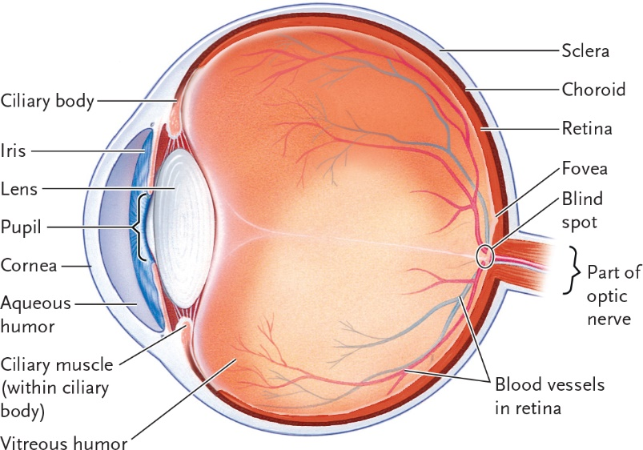

________________________________________________________________________

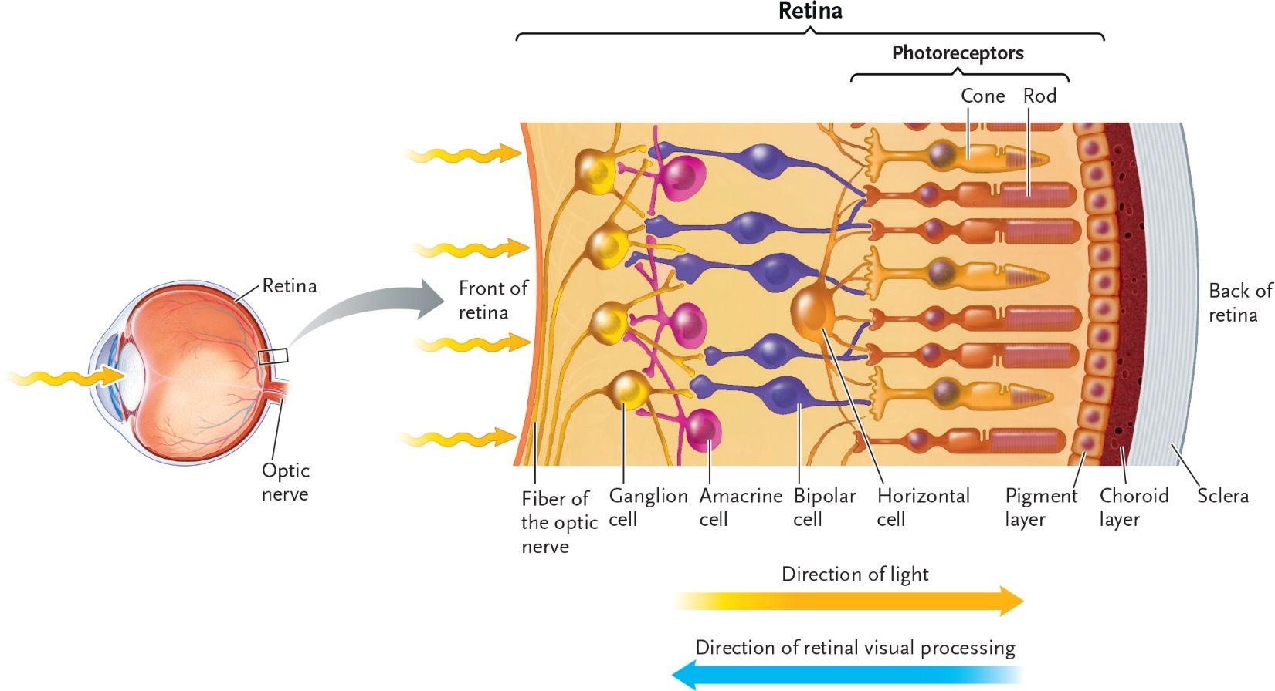

11-2

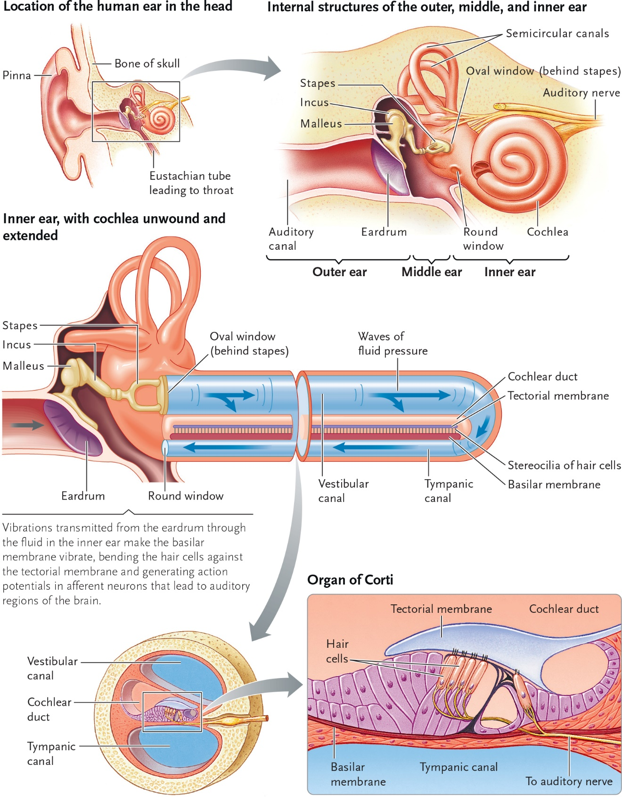

11-3

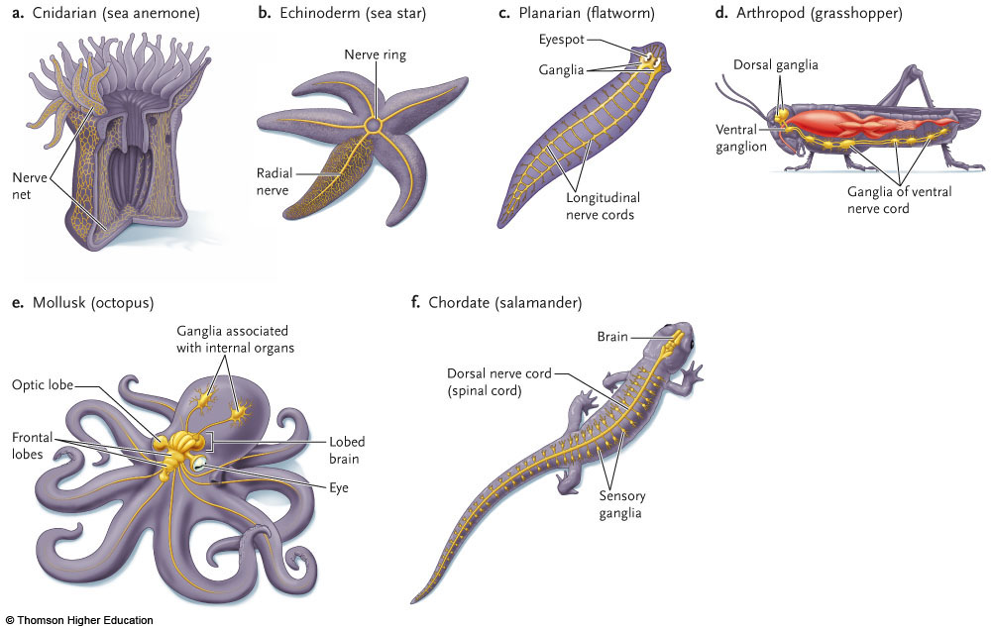

11-4

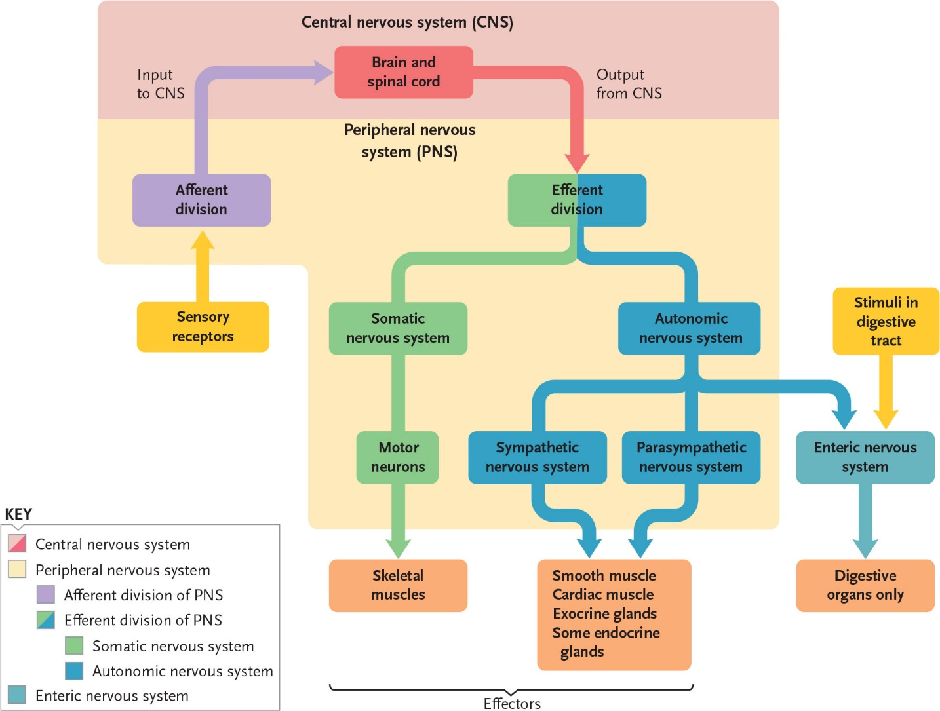

11-5

AUTONOMIC NERVOUS SYSTEM

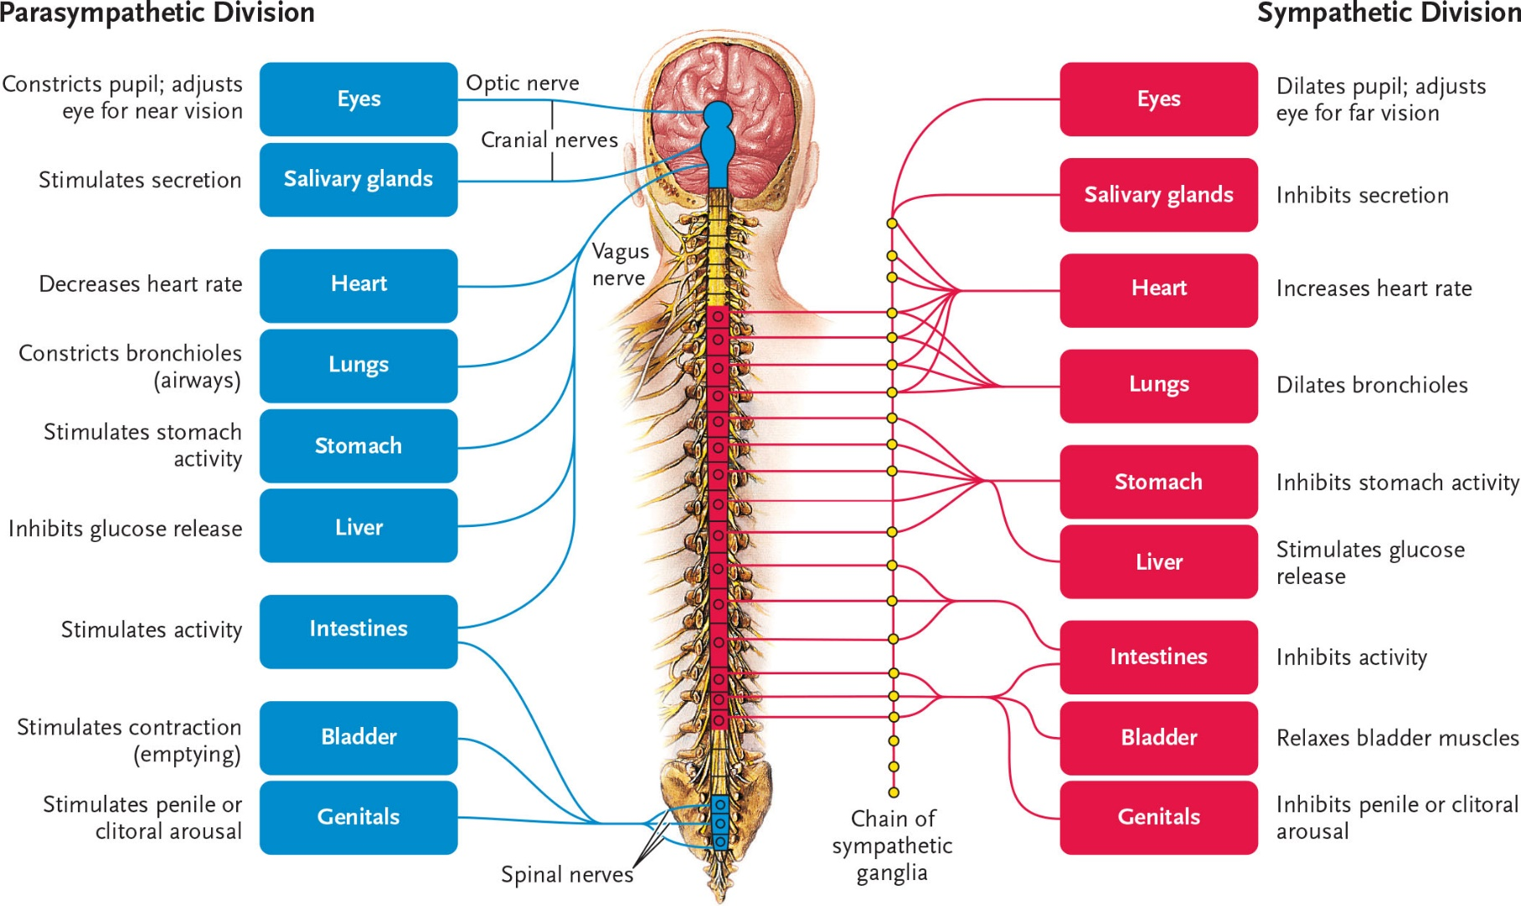

11-6

